SwissCenter & Simese
Windows Installation Guide

Author: Robert Taylor (Swiss)
Creation Date: 3rd July 2005
Last Updated: 3rd July 2005
Version: Draft A

Contents

Downloading the Software 3
Installing 4
Configuring the SwissCenter Interface 7
Configuring the Showcenter to use the SwissCenter Interface. 8

Downloading the Software
The following is a list of all the software that you will need for a successful installation of the SwissCenter interface for the Pinnacle Showcenter:
- SwissCenter & SImese Installer
Download from http://www.swisscenter.co.uk/
Total download size is just under 4 Mbytes.
Please Note: The software supplied with your Pinnacle Showcenter does not need to be installed on your computer to allow you to use the SwissCenter. However, you will need the Pinnacle software installed if you wish to upgrade the Showcenter firmware.

Installing
Having downloaded the SwissCenter & Simese Installer file, double-click it to start the installer and follow the steps below:
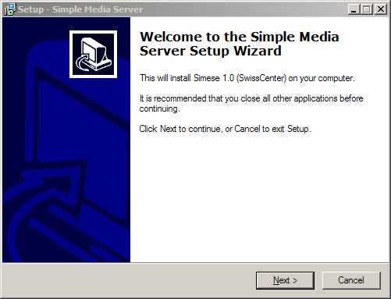 | Step 1  Click Next

Step 2  Enter the location where Simese should be installed. The default location of “C:\Program Files\Simese” should be fine for the majority of installations.  Click Next to continue. | - 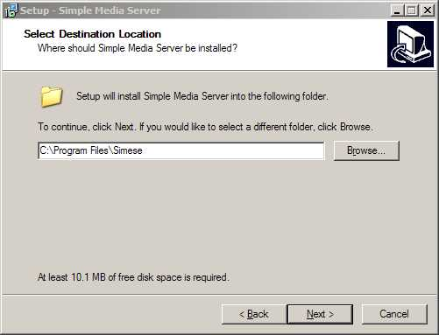

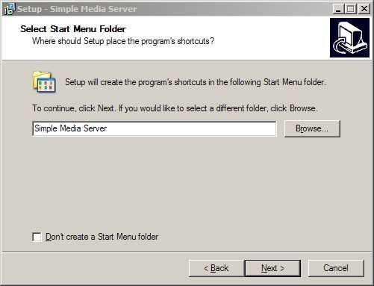 | Step 3  If you wish, change the location where Simese’s shortcuts will be created or choose to not create shortcuts on the start menu.  Click Next to continue.

Step 4  It is highly recommended that you se Simese to start whenever Windows starts up to ensure that you can use your ShowCenter at all times.  Click Next to continue. | - 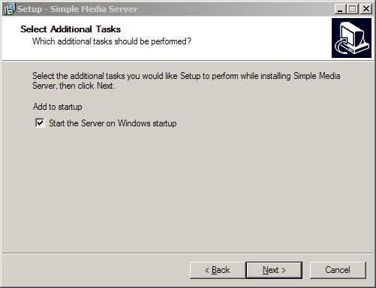

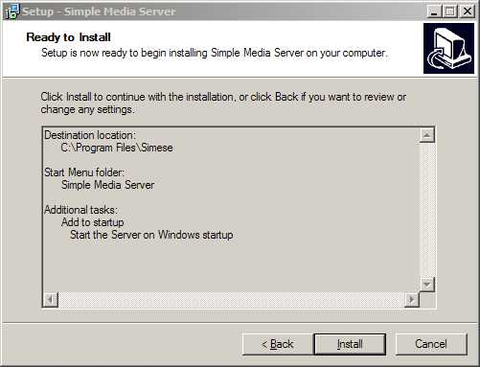 | Step 5  Review the installation details and click Install.

Step 6  Leave the “Start the Simple media Server” option ticked and then click on Finish. | - 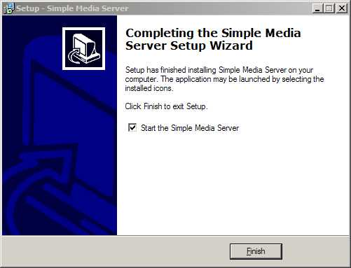

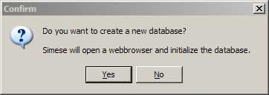 | Step 7  Internet Explorer will start and as this is the first time that you have run Simese you will be prompted to create a new database.  Click on Yes and the SwissCenter database will be created. This may take approximately 60 seconds.

Configuring the SwissCenter Interface
The configuration of the SwissCenter Interface is identical regardless of which operating system you installed the software onto as it uses a web-based front-end. A more detailed guide on how to configure the SwissCenter is available online at www.swisscenter.co.uk , however the basic steps for getting the SwissCenter up-and-running are as follows:
Step 1
Go to the SwissCenter Configuration Utility by entering the following URL into Internet Explorer:
http://localhost:8080/config
Step 2
Click on the "Media Locations" option in the menu and you will be taken to the screen shown below. This is where you specify the locations of the media files that you want to make available via the SwissCenter interface.
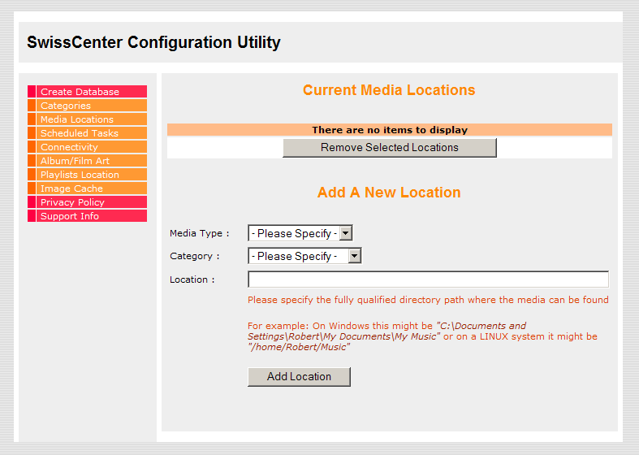
Select the type of media files that you would like the SwissCenter to search for, the Category in which they should appear and the location where the files can be found, then click on Add Location. You can add as many locations as you wish.

Configuring the Showcenter to use the SwissCenter Interface.
When you turn on your Showcenter box it will automatically detect the SwissCenter interface and you will see the name of your PC listed under the heading Media Server Status. Simply press the number of the Media Server that you wish to use.
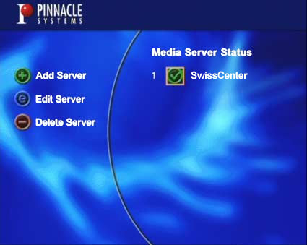
You will now see the SwissCenter main menu. The first thing that you will want to do is to perform a search for new media so that all your files are available for you to watch or listen to.
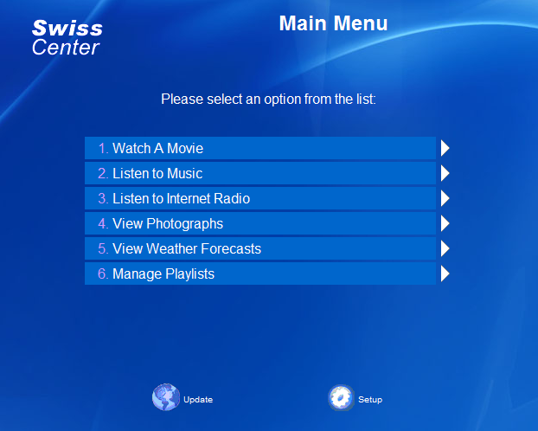
Navigate down to the "Setup" icon using the remote control and select it. You will now be presented with the Setup options:
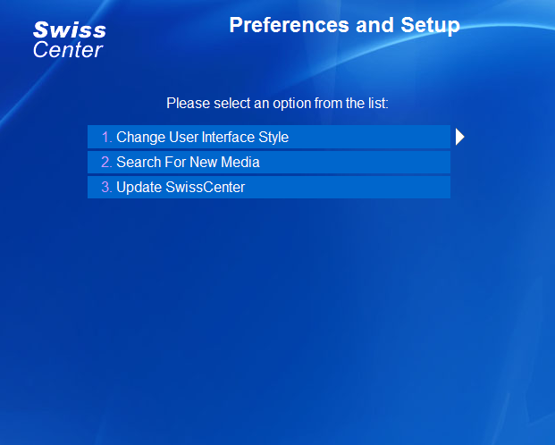
Navigate down to the "Search For New Media" option and select it. The media search will begin and you will see the following screen:
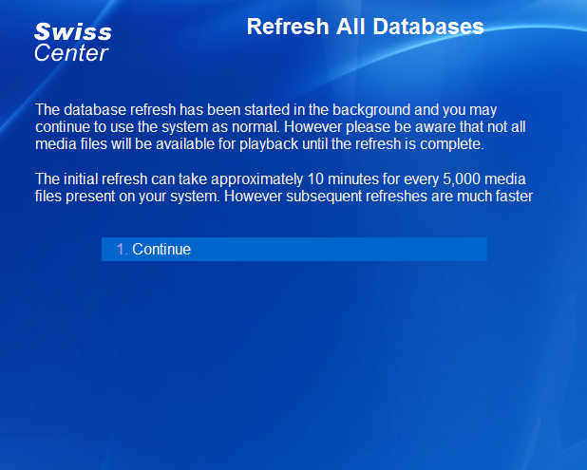
That's it – in a few minutes your media will have been added to the SwissCenter database and you can start using your SwissCenter!

